科目目：現代イギリス社会 WEEK ３: Education Week 3
Contemporary British Society (Spring/2) 担当者名：Peter O’Connor
Education
‘Don't let your boy's schooling interfere with his education.’ –Mark Twain
- Education and class
- Schools: private schools and public schools
- Universities: Oxbridge, Redbrick, New
- The Future: the Academies movement
- Education and class
Education is also socialization. Your education affects not just your thinking but your manners and the way you speak. Education is a marker of social status, in Britain as much as in Japan, any European country and the United States, where college fees are a major obstacle for people from underprivileged backgrounds.
In British society, education can open the way to social mobility. A working class person who goes to Oxford or Cambridge can move into the middle classes, marry well, and go even higher. These universities are miniature versions of country houses. An aristocratic arrangement of clubs, societies, social networks and so on ensures that Oxbridge students can learn how to speak and think like members of the upper classes. There are considerable advantages in going to a highly regarded college at Cambridge or Oxford, in terms of employment and social opportunities. In fact, for many young people, the only escape from a disadvantaged position in society is through education.
In the 1960s, ending in the 1980s, young people from difficult backgrounds benefited from the Assisted Places scheme. This meant that intelligent schoolchildren from a working class background could go to a good boarding school or public school. There they could benefit from an excellent private education at no cost to their family. Your instructor on this course benefited from the scheme.
- Schools: state schools and public [private] schools
Here is Chiswick School, formerly Chiswick County Grammar School. It is a state school. Education here is free:

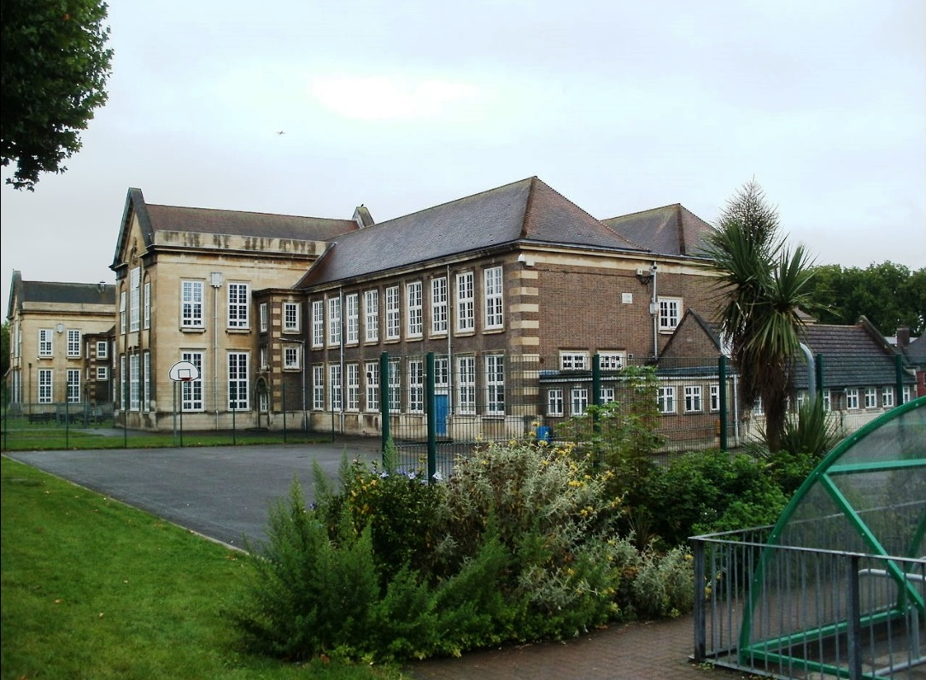
Here is a school called Frensham Heights. http://www.frensham.org/school/ Frensham is a coeducational boarding school in Surrey, about 50 miles from London. The fees are about £40,000 per annum. By and large, Frensham Heights is essentially a school for the children of wealthy people, but this was not always the case.
- Universities: Oxbridge, Yorkwick (York and Warwick), Redbrick (Reading, Sussex, Essex), New (Bedfordshire, Tottenham UTC, Loughborough, Essex)
There is a ranking for universities which is hard to change, just as there is in Japan and in most countries. The top jobs go to people from the top universities. If you go to a good fee-paying public school, you have a better chance of entering a top university, although Oxbridge and Yorkwick have tried hard to change this situation.
- Gonville & Caius College, Cambridge: http://www.cai.cam.ac.uk/
- York University: http://www.york.ac.uk/
- Reading University: http://www.reading.ac.uk/
- Tottenham University Technical College:
- http://www.tottenhamutc.co.uk/
4. The Future: the Academies movement: Chiswick County Gramar is now called Chiswick School and it is an Academy School. Academy schools enjoy a special status, get government grants for improvement, and teach a freer and more interesting range of subjects than regular state schools. There are plans to give all secondary (11-18) schools in Britain Academy status.
‘Don't let your boy's schooling interfere with his education.’ – Mark Twain
What did Mark Twain mean?

